Ch.1-4 Test
STUDY GUIDE
Vocabulary Directions: Review the definitions of each of the following words. When you feel you know them all have someone quiz you.
indentured servant Intolerable Acts Jamestown cash crop
mercantilism Stamp Act Puritans French Indian War
salutary neglects Sugar Act Massachusetts Bay Quebec
Coureurs de bois Boston Massacre Boston Tea Party

Matching Directions: Place the letter of each word or phrase on the line it best matches with.
- Jamestown B. Quartering Act C. Join or Die D. Pennsylvania
E. Pilgrims F. Tobacco G. Tea Act H. Sugar Act
I. Northern Colonies J. Middle Colonies K. Southern Colonies

- came to Plymouth, Massachusetts for religious freedom.
- life was difficult in this early settlement until they began growing tobacco
- William Penn started a colony as a “holy experiment” to act as a haven for all religions
- Benjamin Franklin created a political cartoon of a snake that symbolized the need for the colonies to unite as one against a common enemy
- Life flourished and became successful in Jamestown with this cash crop
- Britain imposed this tax on the most popular consumer item in the colonies
- forced colonists to house British soldiers
- First tax Britain imposed on colonists. Caused an increase in smuggling.
- Known for shipbuilding and fishing to sustain their economy
- known for tobacco and agriculture
- known for religion, fur trading and diverse population

Fill in the Blank:
- _____________________________ was the first colony to be established.
- _____________________________ has control over the colonies.
- Pennsylvania was founded by _____________________________.
- Quakers were disliked by the British because they would not participate in ____________.
- Rhode Island was the first colony to promote______________________ freedom.
- Georgia was created and founded by _________________________.
- Massachusetts Bay Colony was founded by _______________________________.
- _________________________ last colony to be established.
Short Answer Directions: Read the following questions carefully and answer in complete sentences.
- What major cash crop was grown in Jamestown, Virginia?
__________________________________________________________________________________________________________________________________________________________________________________________________________________________________________________________________________________________________________________________________________
- Describe the Northern, Middle, and Southern Colonies? What did they have in common? What was unique to each region?
Commercial North/  New England | Religious  Middle | Agricultural  South
unique to region | unique to region | unique to region
common to all 3 regions

- List at least 3 Acts or events that led the colonists to rebel against British government?
__________________________________________________________________________________________________________________________________________________________________________________________________________________________________________________________________________________________________________________________________________
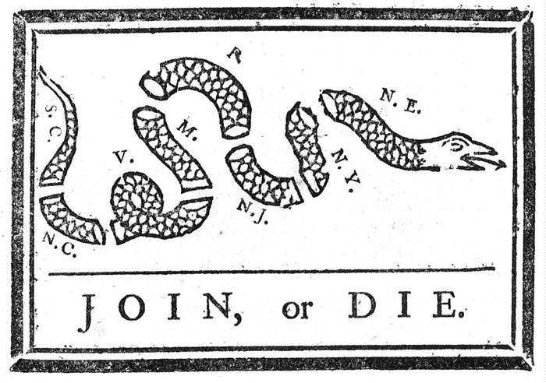
- Describe the importance of the political cartoon below.

_______________________________________________________________
_______________________________________________________________
_______________________________________________________________
_______________________________________________________________
_______________________________________________________________
_______________________________________________________________
5. What caused the British to impose taxes on the colonists?
__________________________________________________________________________________________________________________________________________________________________________________________________________________________________________________________________________________________________________________________________________________________________

